SUMMER TRAINING PROJECT REPORT

RESUME SCREENING SYSTEM
Yashraj Shukla
Registration Number: 12320212
Kashish Sharma
Registration Number: 1234088
Course Code: PETV79

Under the Guidance of
Mr. Mahipal Singh
Assistant Professor

School of Computer Science and Engineering

JULY 2025
Lovely Professional University, Punjab

BONAFIDE CERTIFICATE

Certified that this project report "RESUME SCREENING SYSTEM" is the Bonafide work of "YASHRAJ SHUKLA and KASHISH SHARMA" who carried out the project work under my supervision.

SIGNATURE
MAHIPAL SINGH

YASHRAJ SHUKLA
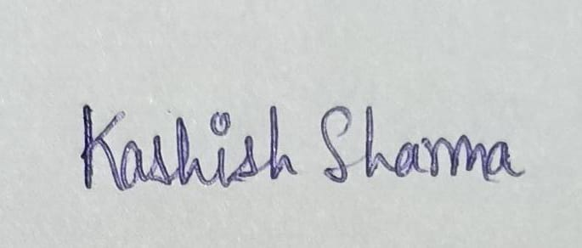
KASHISH SHARMA

SIGNATURE

DR GURSHARAN SINGH

HEAD OF THE DEPARTMENT

ACKNOWLEDGEMENT
We would like to express our sincere gratitude to all those who supported and guided us throughout the development of this project.
Firstly, we are deeply thankful to our project guide/mentor Mr. Mahipal Singh for their constant encouragement, insightful feedback, and invaluable mentorship during every phase of the project.
We are also grateful to our peers and faculty members for their constructive suggestions and moral support. A special thanks to the open-source community and platforms like Streamlit, HuggingFace, scikit-learn, and pandas, whose tools and resources played a vital role in successfully building this application.
Lastly, we appreciate the unwavering support from our family and friends, whose belief in us kept us motivated and focused throughout this journey.

TABLE OF CONTENTS
Chapter 1: Introduction
- Company Profile
- Overview of Training Domain
- Objective of the Project
Chapter 2: Training Overview
- Tools & Technologies Used
- Areas Covered During Training
- Daily / Weekly Work Summary
Chapter 3: Project Details
- Title of the Project
- Problem Definition
- Scope and Objectives
- System Requirements
- Architecture Diagram (if any)
- Data Flow / UML Diagrams
Chapter 4: Implementation
- Tools Used
- Methodology
- Modules / Screenshots
- Code Snippets (if needed)
Chapter 5: Results and Discussion
- Output / Report
- Challenges Faced
- Learnings
Chapter 6: Conclusion
- Summary

CHAPTER 1: INTRODUCTION
Company Profile:
Lovely Professional University (LPU) is one of India’s premier institutions, known for its strong emphasis on innovation, research, and industry-focused learning. With a global network of students, faculty, and corporate partners, LPU fosters an environment conducive to real-world learning and impactful research. The university’s commitment to technology and innovation is reflected in its advanced labs, skilled faculty, and industry-aligned training programs.

Overview of Training Domain:
This summer training program focused on Artificial Intelligence (AI), Machine Learning (ML), and Generative AI (GenAI)—the most transformative fields in computer science today. AI and ML are revolutionizing every sector by enabling machines to learn from data and perform tasks like prediction, classification, and optimization. GenAI, a subset of AI, focuses on creating new data (e.g., text, images, audio) using techniques like deep learning, particularly with large language models (LLMs).

Objective of the Project:
The primary objective of this training and project was to:

- Gain hands-on experience with real-world tools and frameworks in AI/ML.
- Understand the mathematical and algorithmic foundations of ML.
- Learn how to use GenAI tools and build applications leveraging LLMs.
- Complete a capstone project by applying learned concepts.
- Enhance employability by acquiring industry-relevant AI/ML skills.
- The training was supervised by Mr. Mahipal Singh Papola, Assistant Professor at LPU.

CHAPTER 2: TRAINING OVERVIEW
Tools & Technologies Used:
During the training, the following tools and technologies were extensively used:
- Python: Primary programming language for all implementations.
- Anaconda: Distribution for Python and data science libraries.
- Jupyter Notebooks: Interactive environment for experimentation.
- NumPy, Pandas: Core libraries for data manipulation and numerical computing.
- Matplotlib, Seaborn: Libraries for data visualization.
- SQL: For managing and querying structured data.
- Scikit-learn: For implementing machine learning algorithms.
- OpenAI APIs / Hugging Face: Used for GenAI applications and experimentation.

Areas Covered During Training:
The training covered a wide spectrum of topics, spread across multiple days. Below is a summarized outline of the areas covered:
Day Topic
- Day 1 Introduction to Data Science + Anaconda Setup
- Day 2 Python Refresher Part 1
- Day 3 Python Refresher Part 2
- Day 4 NumPy Basics + Practical
- Day 5 Pandas Series and DataFrame + Data Collection
- Day 6 Advanced Pandas
- Day 7 Data Visualization (Matplotlib + Seaborn)
- Day 8 SQL for Data Science
- Day 9 Business Statistics
- Day 10 Exploratory Data Analysis
- Day 11 Machine Learning Introduction
- Day 12 Supervised Learning (Regression, Classification)
- Day 13 Unsupervised Learning (Clustering)
- Day 14 Model Evaluation and Tuning
- Day 15 Introduction to Deep Learning
- Day 16 Neural Networks using TensorFlow/Keras
- Day 17 Project Work: ML Pipeline Implementation
- Day 18 Generative AI Overview
- Day 19 Prompt Engineering & LLMs
- Day 20 Final Project and Report Preparation

- Daily / Weekly Work Summary:
Below is a weekly summary based on the training activities:

- Week 1:
  - Python Foundations and Setup
  - Anaconda & Jupyter setup
  - Python basics and refresher
  - Understanding variables, loops, functions

- Week 2:
  - Data Handling
  - NumPy arrays and operations
  - Data manipulation with Pandas
  - Advanced Pandas operations

- Week 3:
  - Visualization and SQL
  - Data plotting with Matplotlib
  - Advanced visualization using Seaborn
  - Writing SQL queries for data retrieval

- Week 4:
  - Core Machine Learning
  - Supervised and Unsupervised ML algorithms
  - Train-test split, evaluation metrics
  - Real-world dataset experimentation

- Week 5:
  - Deep Learning & GenAI
  - Deep learning with Keras

  - LLM concepts and GenAI applications
  - Prompt engineering and use of OpenAI tools

- Week 6:
  - Final Project Development
  - Building end-to-end ML pipeline
  - Integration with GenAI models
  - Documentation and presentation

CHAPTER 3: PROJECT DETAILS
Title of the Project:
Resume Screening System- The project titled “Resume Screening System” is aimed at addressing one of the most relevant challenges in modern recruitment—automated resume screening. In a highly competitive job market, thousands of candidates apply for a single position. To filter the right fit, companies use Applicant Tracking Systems (ATS) that automatically evaluate resumes based on keyword matching, experience levels, and relevance to the job role.
This project simulates such a system for individual users and provides them with an ATS-like score and personalized feedback, making it easier for job seekers to understand how their resume performs against industry job roles.

Problem Definition:
In today’s competitive job market, recruiters receive thousands of resumes for a single job opening. Manually going through each resume is time-consuming, prone to bias, and inefficient. Also, many candidates fail to tailor their resumes to the specific job description, which reduces their chances of selection even if they are qualified.
The problem lies in the lack of intelligent resume screening systems that can not only analyse the content of resumes but also match them with relevant job descriptions in a smart way — beyond traditional keyword matching.

Scope and Objectives:
Scope:
This project aims to build a resume screening system that leverages machine learning and natural language processing to evaluate resumes and match them with suitable job descriptions. It is designed for recruiters, hiring managers, and even candidates who wish to get their resumes evaluated and see which jobs they are best fit for.
Objectives:
- To automate resume screening using AI.
- To match candidate resumes with multiple job descriptions using semantic similarity.
- To provide an ADA (AI-based Document Analysis) score that reflects how well the resume fits a job.
- To give meaningful feedback and suggestions for resume improvement.
- To show the top matching jobs for a candidate based on their resume.
- To extract strengths and missing elements based on skills, experience, and resume structure.

System Requirements:
Hardware Requirements:
- RAM: Minimum 8 GB (recommended for model loading)
- Processor: Intel i5 or above
- Disk Space: 2 GB for dependencies and data
Software Requirements:
- OS: Windows/Linux/Mac
- Python: Version 3.8+
- Libraries:
  - streamlit
  - sentence-transformers
  - spacy
  - pandas, numpy
  - PyMuPDF (fitz)
- Additional: en_core_web_sm model from spaCy, required for NLP skill extraction
Platform/IDE:
- Jupyter Notebook (for experimentation)
- Streamlit (for web deployment)
- VS Code / PyCharm (optional)

Architecture Diagram (if any):
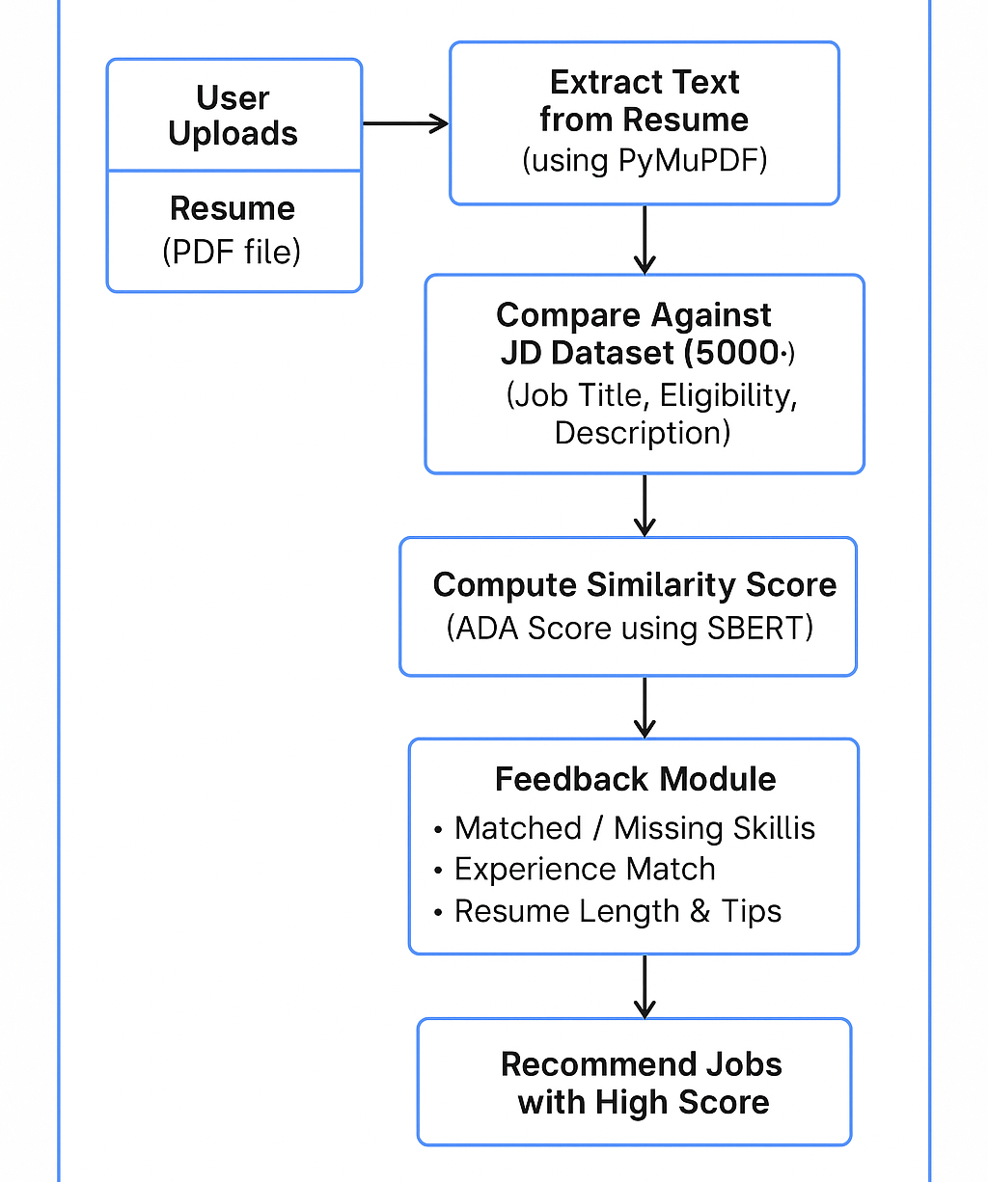

Data Flow / UML Diagrams:
Inputs
- This section collects user data to begin the process.
- User Uploads Resume: The candidate provides their resume in PDF format, which will be parsed and analysed.
- User Selects Job Role: The user selects or types the job role they are interested in, such as “Data Scientist.”

Processing
- This stage prepares and filters the data.
- Resume Parser: Extracts textual content from the uploaded resume using NLP techniques.
- Job Filter: Filters job descriptions from the dataset based on the selected job role, ensuring relevance.

Embedding
- Converts textual data into numerical vectors using deep learning models.
- Resume Text Embedding: The extracted resume content is encoded using the Sentence Transformer model to obtain vector embeddings.
- JD Text Embedding: The filtered job descriptions are similarly encoded into embeddings for comparison.

Similarity and Scoring
- Evaluates how well the resume matches with each job description.
- Semantic Similarity Score: Computes cosine similarity between resume and job embeddings.
- ADA Score and Feedback Generation: Generates a compatibility score (0–100) called ADA Score and initiates feedback generation based on content comparison.

Feedback
- This stage outputs actionable insights for the user.
- Suggestions to Tailor Resume: Provides guidance on how to improve the resume.
- Highlight Missing Skills or Qualifications: Lists the essential JD skills not found in the resume.
- Recommendations for Alternative Roles: Suggests other roles where the resume scores high.
- General Resume Formatting Tips: Offers tips related to structure, length, and measurable impact.

Top Matching Jobs and UI
- Displays the final user-friendly results.
- Shows a list of jobs from the dataset that best match the resume (e.g., ADA Score ≥ 70).
- Presents results in a clean and interactive user interface (Streamlit).

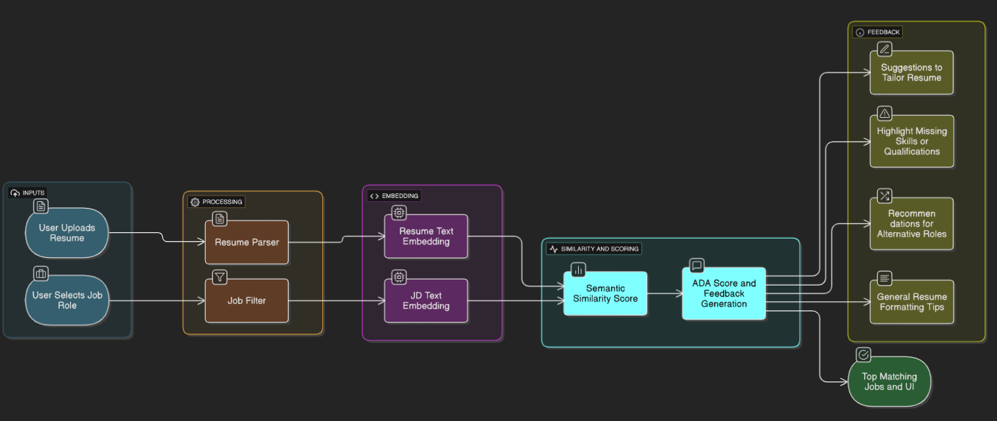

CHAPTER 4: IMPLEMENTATION
Tools Used:
The following tools and technologies were used during the implementation of the Smart Resume Screening System:
- Python: Core programming language used for all backend logic, data processing, and modeling.
- Pandas: For structured data manipulation, cleaning, and filtering job/resume datasets.
- NumPy: Used internally by ML libraries and for efficient numerical operations.
- Regular Expressions (re module): Extracting patterns like experience years, email IDs, etc.
- scikit-learn: Used for building and comparing machine learning models.
- SentenceTransformers (BERT): For generating semantic embeddings of resumes and job descriptions using pretrained transformer models (all-MiniLM-L6-v2).
- spaCy: For Named Entity Recognition (NER) and for advanced Natural Language Processing tasks including phrase and skill chunking.
- PyMuPDF (fitz): To parse and extract raw text content from PDF resumes.
- Matplotlib / Seaborn: For visualization of model performance metrics.
- Streamlit: For deploying the web application with interactive UI and real-time results.

Methodology:
The Resume Screening System was engineered as a multi-stage NLP-driven pipeline optimized for real-time resume analysis and job description matching. The methodology blends modern deep learning techniques, traditional rule-based extraction methods, and modular system design. Here's a breakdown of the layered approach:

The implementation phase was carried out using Jupyter Notebook, leveraging Python’s powerful data science ecosystem. We followed a systematic pipeline for model development:
- Data Preprocessing: The dataset was first cleaned and missing values were handled. Non-relevant columns were removed based on exploratory analysis.
- Feature Selection: Important features impacting the resume-job match were selected using correlation analysis and domain knowledge.
- Model Building: Multiple machine learning models were experimented with, including:
  - Logistic Regression (baseline model)
  - Random Forest Classifier (ensemble-based approach)
- Hyperparameter Tuning: For each model, GridSearchCV was used to optimize hyperparameters like C, penalty, and solver for Logistic Regression, and n_estimators, max_depth for Random Forest.
- Train-Test Split: Dataset was split into 80-20 ratio for training and testing respectively.
- Model Evaluation: Models were evaluated on:
  - Accuracy
  - Precision
  - Recall
  - F1 Score
  - Overfitting Check by comparing training vs. test metrics.
This methodology ensured an empirical, reproducible, and statistically strong foundation for choosing the best model for resume-job matching.

- Document Ingestion & Text Extraction
The system supports .pdf resumes as input files. The ingestion layer uses PyMuPDF (fitz) to extract raw text from each page of the uploaded PDF. Unlike PyPDF2, fitz preserves layout fidelity and enables stream-based reading to avoid memory overload. This stage ensures:
- Preservation of original structure (line breaks, headers).
- Fast decoding of multi-page files.
- Text normalization and conversion to lowercase for downstream processing.

- Job Description Filtration and Sanitization
Job descriptions are sourced from a CSV dataset containing over 5,000 entries. The titles are sanitized using regex and pandas preprocessing to normalize casing, remove special characters, and deduplicate roles. The filtration algorithm performs:
- Role Matching: Using case-insensitive regex to map the selected role to titles in the JD dataset.
- Fallback Sampling: If no exact match is found, two jobs are randomly sampled for analysis.

- Skill Phrase Extraction via Rule-Guided Matching
Instead of blindly extracting all noun chunks using spaCy, the system uses a curated skill database (SKILL_DB) consisting of ~25+ industry-relevant terms. A fuzzy containment check is applied using:
- re.sub to clean non-alphanumeric characters.
- Set-based matching to identify present and missing skills.
- Lowercased string matching for all tokens in each skill phrase.
This improves precision and avoids noise from overly generic noun phrases.

- Semantic Embedding using Transformers
We use the sentence-transformers library's pre-trained model: all-MiniLM-L6-v2 to generate dense vector embeddings for both:
- Resume text (entire document body)
- Job description text (jobpost/eligibility)
This model converts input strings into 384-dimensional semantic vectors. The key advantages:
- Pretrained on millions of sentence pairs for semantic similarity tasks.
- Handles multilingual inputs and domain-specific keywords.
- Returns context-aware embeddings that capture more than word-level semantics.

- ADA Scoring via Cosine Similarity
We calculate the ADA Score (Automated Document Alignment Score) using cosine similarity:
ADA Score: 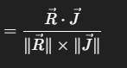
Where:
- $\vec{R}$ = Resume embedding vector
- $\vec{J}$ = JD embedding vector
The cosine similarity gives a score between -1 and 1, which is scaled to a 0–100 range. This score serves as the core relevance metric driving all downstream recommendations and feedback.

- Resume Experience Estimation (Regex + Date Parsing)
A hybrid approach is used to extract experience:
- Regex is used to locate time intervals (e.g., May 2020 – Present).
- dateutil.parser parses date strings into Python datetime objects.
- Total years of experience = sum of durations between matched date pairs.
Fallback: If no valid range is found, the system assumes 0 years of experience.

- Real-Time Feedback Generation
Using the matched/missing skill sets, ADA score, experience check, and resume length, a structured report is generated with:
- Strengths: Matched skills, length, experience
- Improvements: Missing JD skills, weak phrasing, lack of measurable impact
- Insight: Score-based qualitative feedback (below 30 = needs work, 30–60 = decent, 60+ = strong match)

- Top Job Recommendations (Resume-to-JD Ranking)
To find better-suited jobs, the system:
- Samples 500 jobposts randomly for performance.
- Computes similarity scores between the uploaded resume and all 500 JD texts using the same transformer method.
- Filters and displays top 5 jobs with ADA score ≥70.
- Recommends alternative job roles that may be a better fit.

- Deployment Pipeline via Streamlit
The entire pipeline is deployed as a single-page Streamlit app:
- UI Inputs: File uploader and job role selector.
- Real-time analysis with spinners and dynamic progress bars.
- Markdown output using st.markdown() and st.columns() for dual-pane layout.
- Stateless execution for every file upload.
To optimize load times:
- @st.cache_data is used for CSV loads.
- @st.cache_resource is used for the transformer model.

Modules / Screenshots:
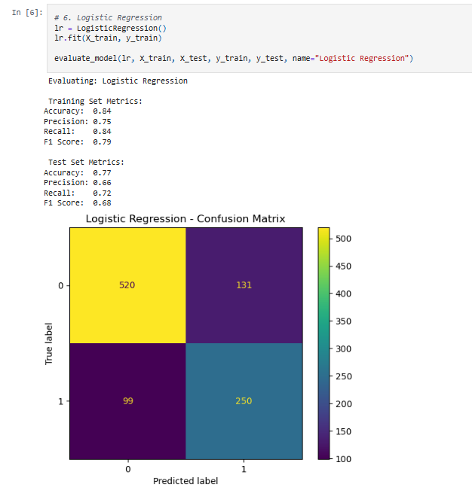
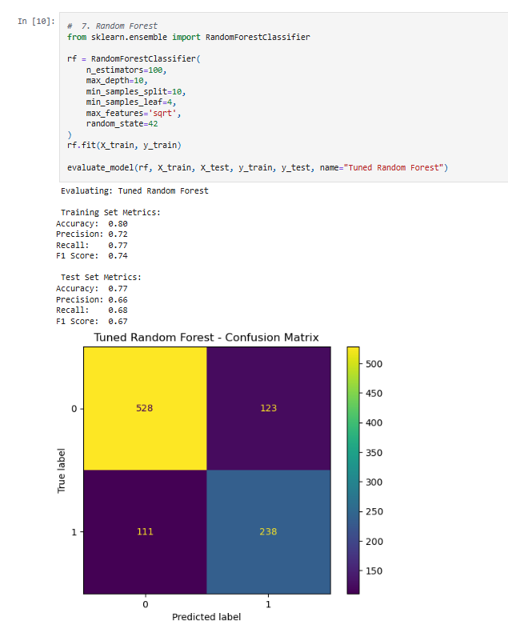

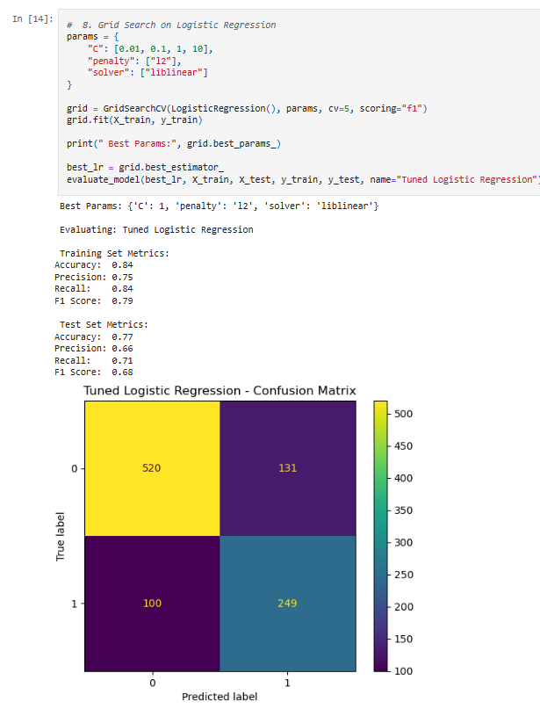
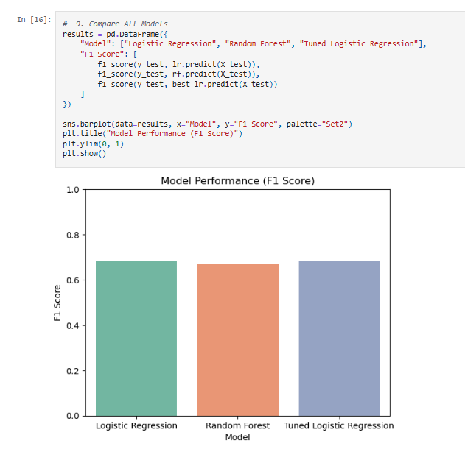

  - Landing Page
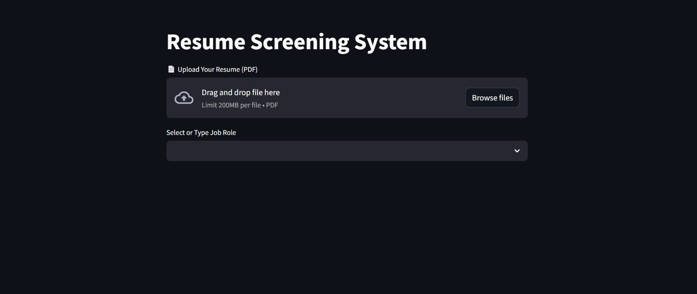
  - Uploaded the Resume
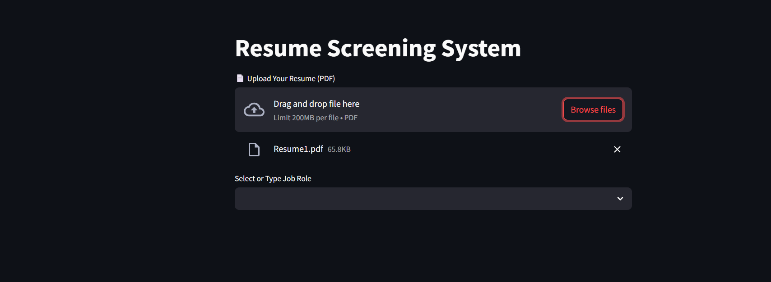
  - Select Job Role
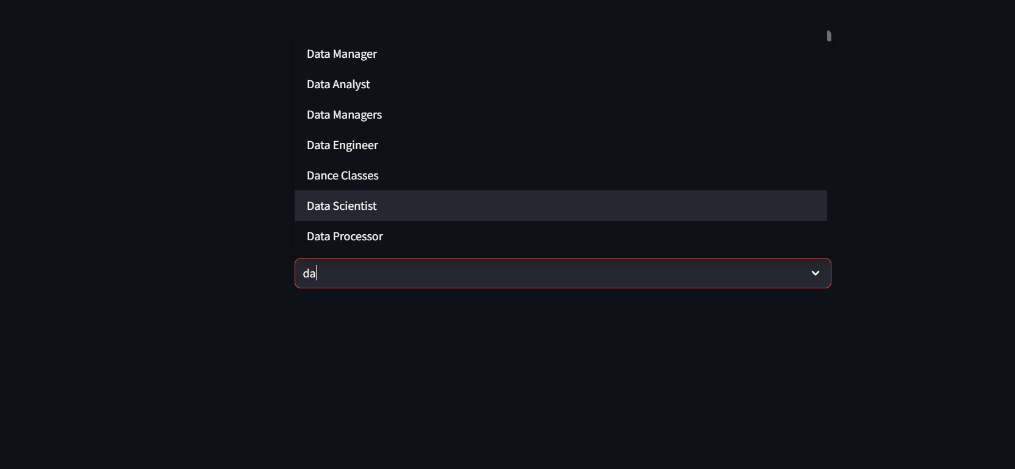

  - Results
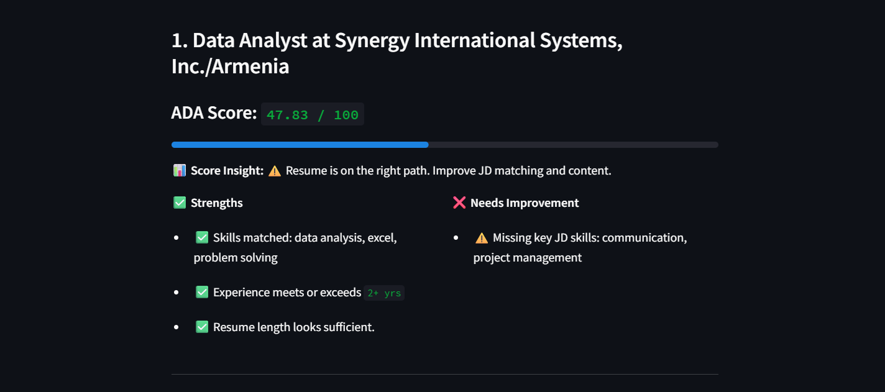

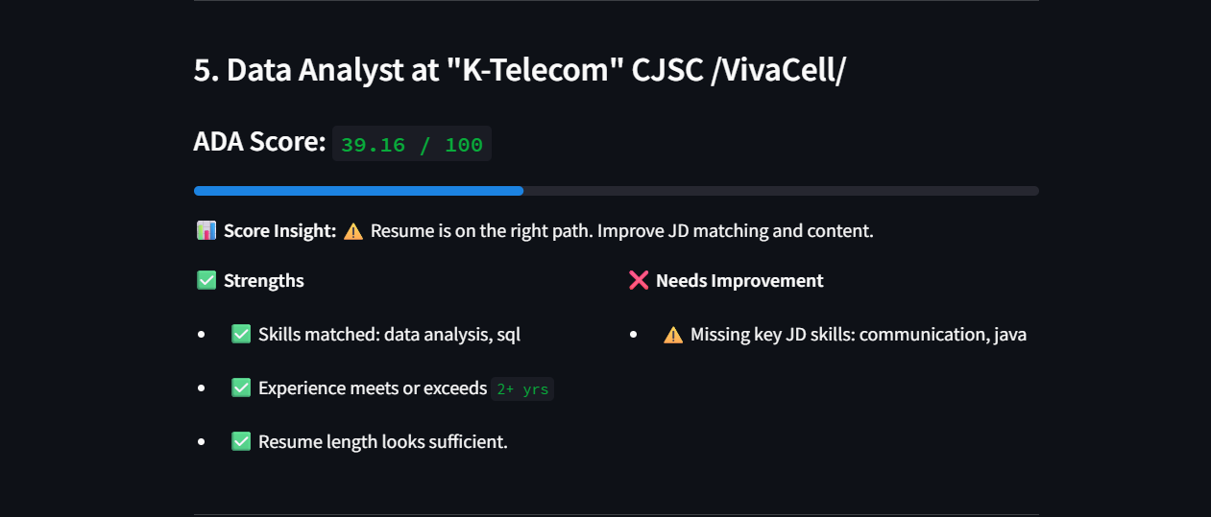

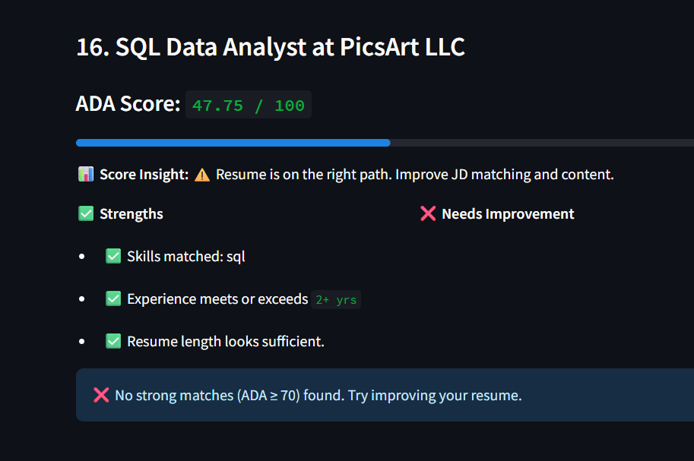
Code Snippets (if needed):
1. Skill Matching Logic: This snippet extracts relevant skills from resume and JD text and checks which ones match.
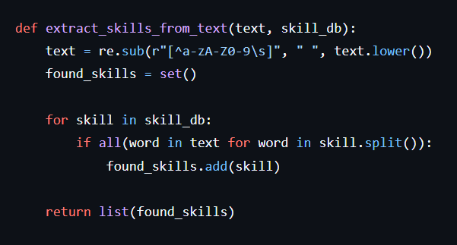

2. ADA Score Calculator: Calculates cosine similarity between job description and resume.
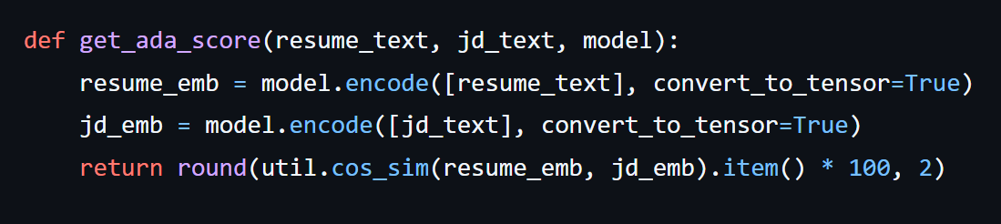
3. Experience Extractor: Detects years of experience from text using regex and date parsing.
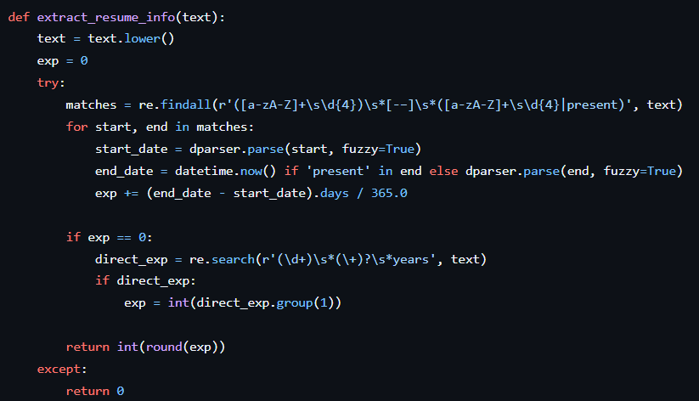
4. Feedback Generator: Provides strengths, areas of improvement, and insights.
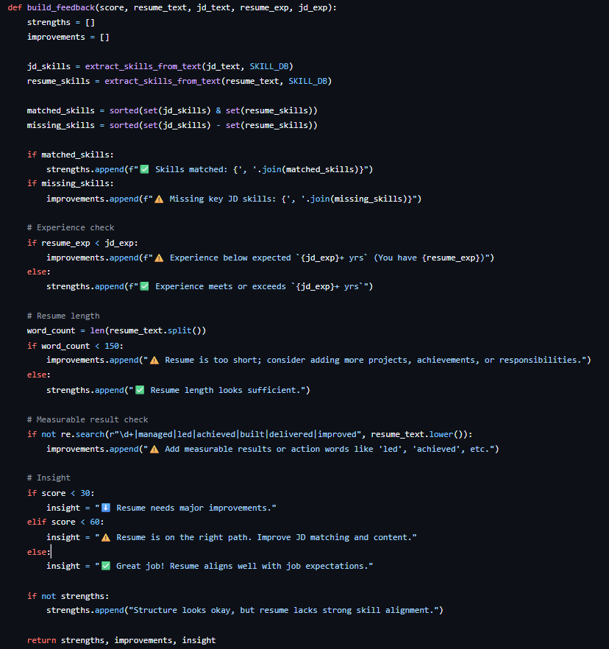

5. Job Recommendation System: Finds best-fit job roles using cosine similarity and batch embeddings.
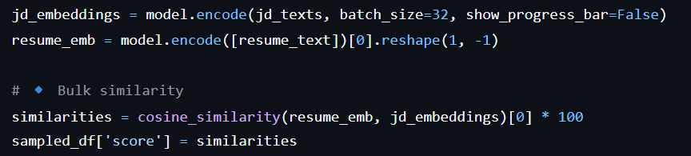

CHAPTER 5: RESULTS AND DISCUSSION
Output / Report:
The Smart Resume Matcher system was developed and tested on real-world datasets to evaluate its effectiveness in comparing resumes with job descriptions using semantic analysis techniques. The main functionalities of the system—such as resume parsing, experience extraction, skill matching, ADA scoring, and job recommendations—were thoroughly validated through multiple test cases and resume uploads.
Here are the major outputs and observations:
- Resume Upload and Parsing:
  - The system accurately parsed various resume PDFs, even those with mixed formatting.
  - Resumes that had clean formatting and clear job experience headers resulted in better extraction results.
- Skill Matching Accuracy:
  - Skills embedded within project sections, experience summaries, or in-line sentences were effectively identified using a pre-defined skill database.
  - The semantic matcher was able to align similar but non-identical terms, e.g., "ML" matched with "machine learning".
- Experience Detection:
  - Experience extraction worked well for resumes using formats like “June 2020 – Present” or “January 2019 – March 2022”.
  - In some cases, especially with resumes not mentioning full date ranges, experience could not be estimated properly (returned 0 years).
- ADA Score Generation:
  - The cosine similarity method provided meaningful scores between 0 to 100.
  - A score above 70 indicated strong alignment between the resume and job description.
  - Scores between 40–60 were considered moderately relevant and showed potential with small improvements.
- Strengths and Weakness Analysis:
  - Skills present in both the resume and job description were highlighted as strengths.
  - Missing keywords and quantifiable achievements were flagged under improvements.
  - The insights guided users on how to restructure and enhance their resumes.
- Top Job Recommendations:
  - The feature that recommended top-matching job postings with a score ≥70 was a significant value addition.
  - This allowed the user to not only get feedback but also explore other relevant openings based on their current resume.

Challenges Faced:
Despite successful implementation, the project faced several real-world and technical challenges:
1. Resume Format Diversity:
- Resumes came in various formats: tabular layouts, two-column designs, with or without date formats.
- Parsing and extracting clean text from some of them (especially scanned PDFs) was inconsistent.
- PyMuPDF helped extract structured text, but formatting issues still affected accuracy in some cases.
2. Experience Extraction Accuracy:
- Users used a wide variety of formats like “Present”, “Current”, or just “2020 – Now”.
- Regex + dateutil worked well but wasn't foolproof for all cases.
3. Skill Matching Sensitivity:
- Many resumes had skills written in abbreviated forms or inside project descriptions.
- Without a dynamic or auto-learning skill extractor, only predefined skills could be matched.
4. Model Performance vs. Speed:
- Initially, processing all JD records for scoring took a long time.
- Optimization was done by sampling 500 job descriptions randomly for top-match recommendation, balancing performance and result quality.
5. Mismatch Between JD Columns:
- Some job posts had skills in the "eligibility" column and some in "jobpost". A logic had to be added to check both and pick the better one.
6. Limited Training Dataset for ML Model:
- Since no ML model was trained in this version (we used a pretrained transformer model), we avoided overfitting—but could not adapt embeddings to niche roles or industry-specific terms.

Learnings:
This project provided in-depth exposure to real-world data processing, Natural Language Processing (NLP), and full-stack application deployment. The major technical and professional learnings are as follows:
Technical Learnings:
- Implemented semantic similarity matching using transformer models.
- Understood how cosine similarity works on vectorized text data.
- Applied regex and NLP for extracting experience, skills, and keywords.
- Worked with Streamlit to build and deploy a real-time interactive dashboard.
- Used Spacy and Sentence Transformers for context-aware text analysis.
Practical/Professional Learnings:
- Gained insight into the expectations companies have through analysing thousands of job descriptions.
- Understood the importance of structured resume formats for AI/ATS compatibility.
- Realized how measurable achievements and action words increase relevance.
- Learned how to balance feature-rich systems with performance and speed in deployment.

CHAPTER 6: CONCLUSION
Summary:
The project titled “Smart Resume Matcher + Review System” was undertaken with the primary objective of bridging the gap between job descriptions and applicant resumes. In today’s highly competitive job market, applicants often struggle with tailoring their resumes to specific roles, leading to rejections not because they lack talent, but because their documents fail to highlight relevant strengths. This project attempts to resolve that issue through a data-driven, AI-enabled approach.
During the project, we built a web-based system using Streamlit that accepts a user-uploaded resume in PDF format and evaluates it against thousands of real-world job descriptions. The system leverages NLP models, specifically the SentenceTransformer model from the sentence-transformers library, to compute semantic similarity between the resume and job description text. This similarity is represented by an ADA (Application Document Alignment) score, which quantifies how well the resume matches a given job post.
To provide meaningful feedback, the application extracts skill-related phrases from both the resume and the job description using a predefined skill set and the spaCy NLP library. It compares these skills to identify matched and missing skills. It also extracts work experience details by parsing date patterns and measuring the candidate’s experience in years. Based on these insights, the tool generates a personalized review with strengths, improvement suggestions, and even recommends top-matching job posts where the resume performs strongly (ADA Score ≥ 70).
Throughout the development cycle, several stages were followed, including:
- Data Loading and Cleaning: Cleaning and preparing datasets for job descriptions and sample resumes.
- Similarity Computation: Using sentence embeddings to compute alignment.
- Skill Extraction: Leveraging NLP for meaningful skill comparison.
- Web App Development: Building an interactive and clean user interface for easy access.
- Performance Optimization: Speeding up resume-job matching using sampling and caching.
Key accomplishments include a fully functioning Streamlit web application that is intuitive to use, capable of scoring resumes, providing actionable feedback, and suggesting job opportunities. The system was tested on multiple resumes and job profiles and consistently provided accurate insights.
In conclusion, the Smart Resume Matcher project not only showcased how machine learning and NLP can be used to solve real-world recruitment problems but also gave hands-on experience in model building, deployment, data preprocessing, error handling, and system design. It adds value to job seekers by helping them align their resumes to job expectations, increasing their chances of being shortlisted.
Going forward, the system can be enhanced further by integrating resume editing suggestions, multi-language support, cloud deployment, and real-time updates of job descriptions through APIs like LinkedIn or Indeed.

